* Michael Smith

Lab5

CSE 460

2/06/2018

Total Points 20

1. Message Queues

Command Studies

* + Msgctl performs the control operation specified by cmd.
  + Msgget returns the message queue associated with the value of the key argument
  + Msgrcv receives then reads the message from the specified queue id.
  + Msgsend sends the message to the queue

Msg1.cpp

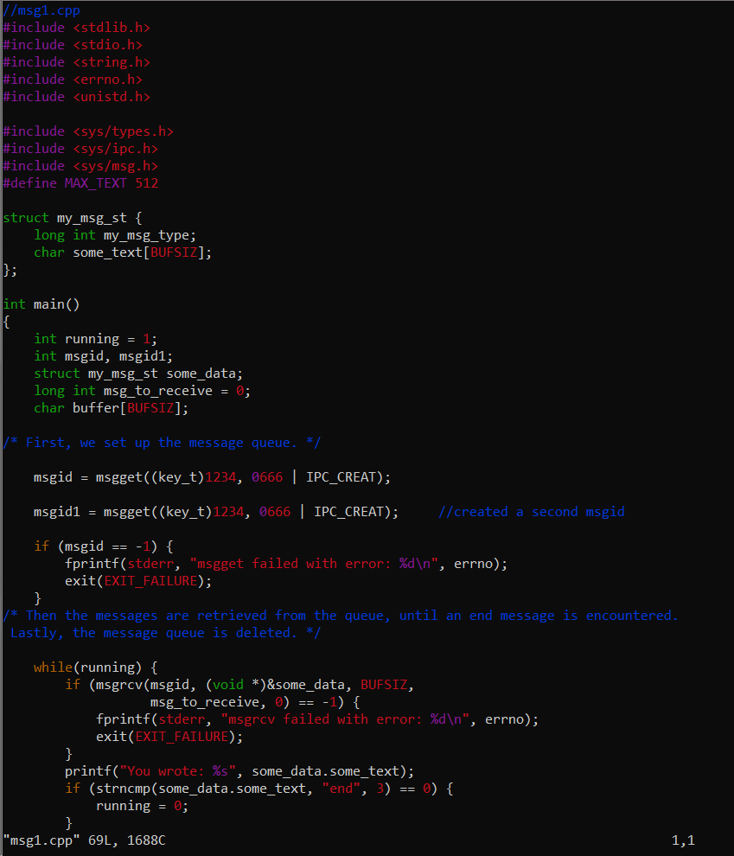

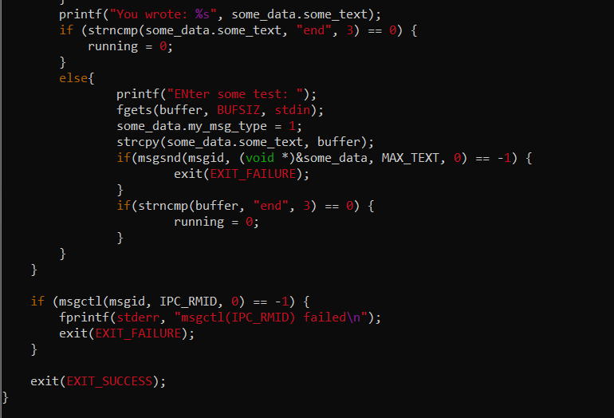

Msg2.cpp

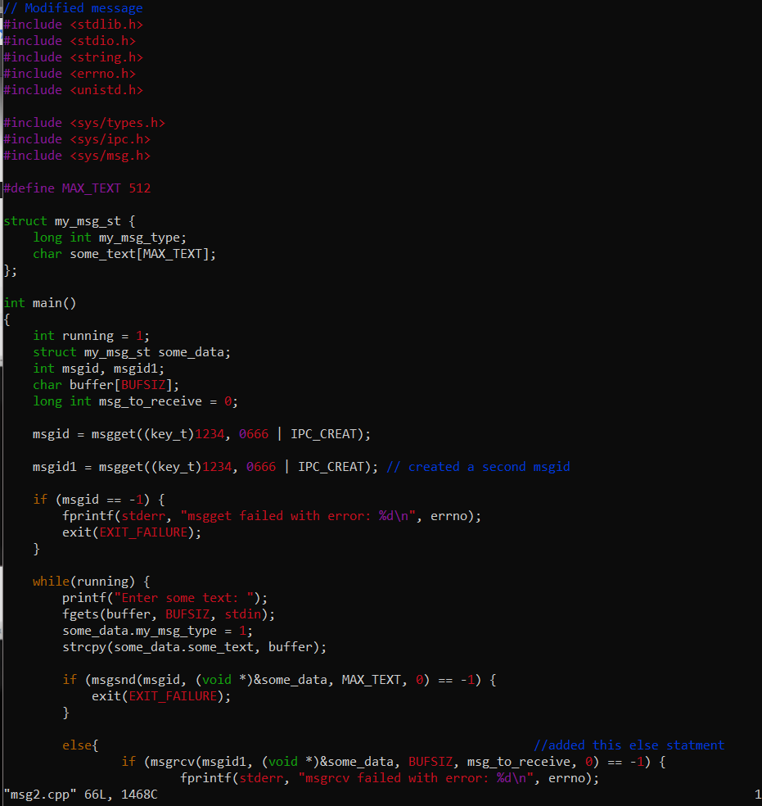

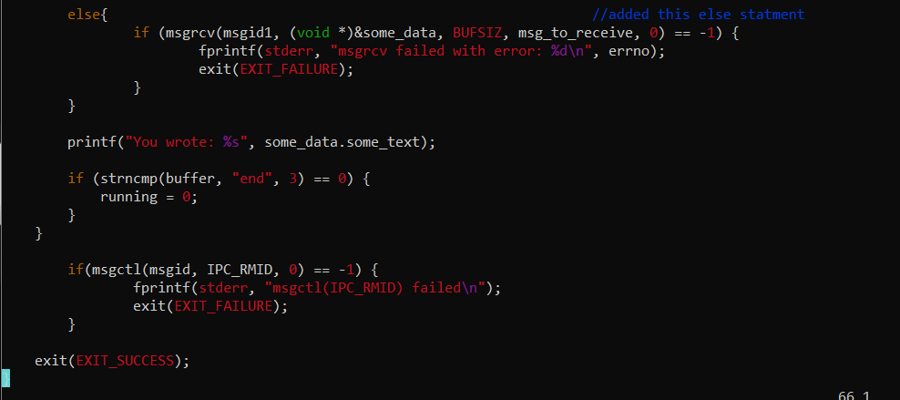

Msgs Output

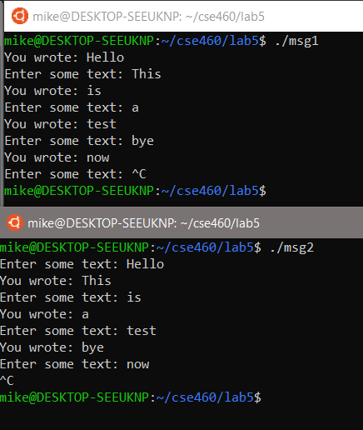

1. IPC Status Commands

Command Studies:

* + Ipcs has three modifiers. -s will identify which process is using semeaphores. And –m identifies which segment of memory is shared. Lastly –q will identify which IPC's semeaphores has messages in its queue.
  + Ipcrm – Removes the interprocess communication with the specified Sem ID

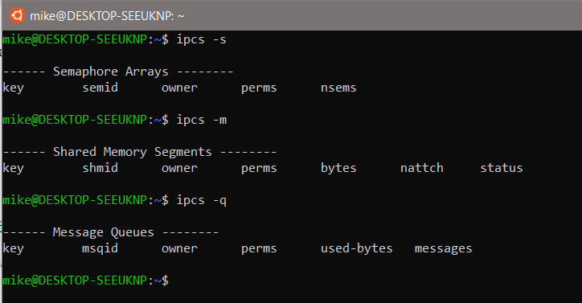

1. Study of XV6

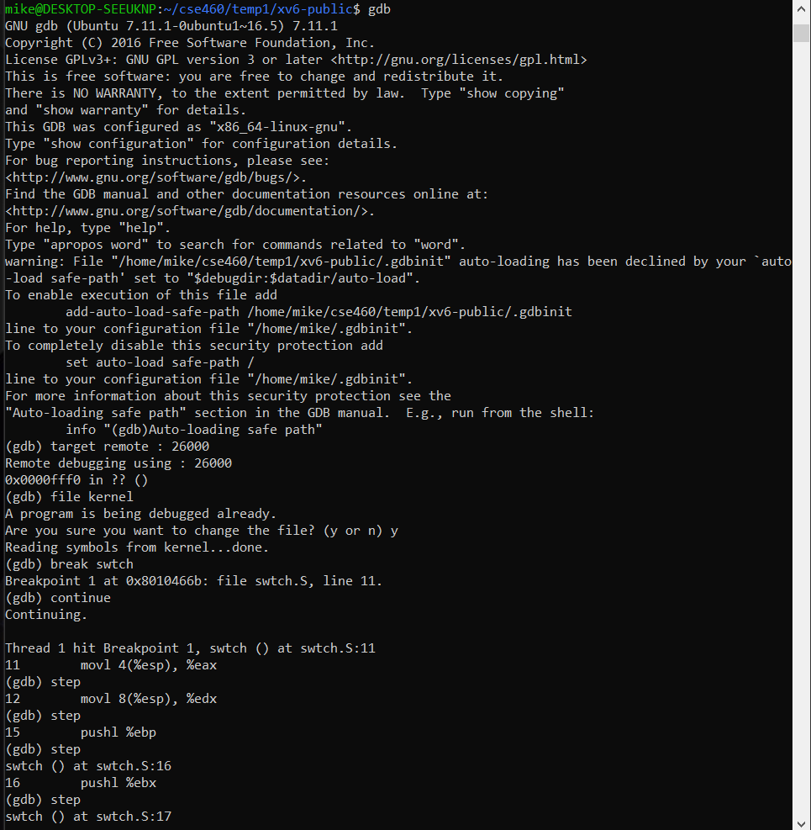

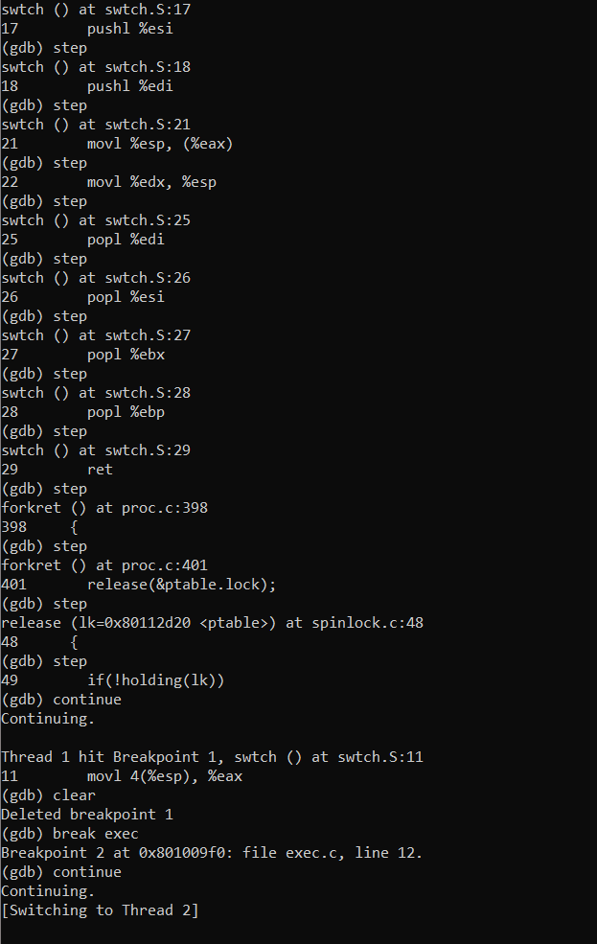

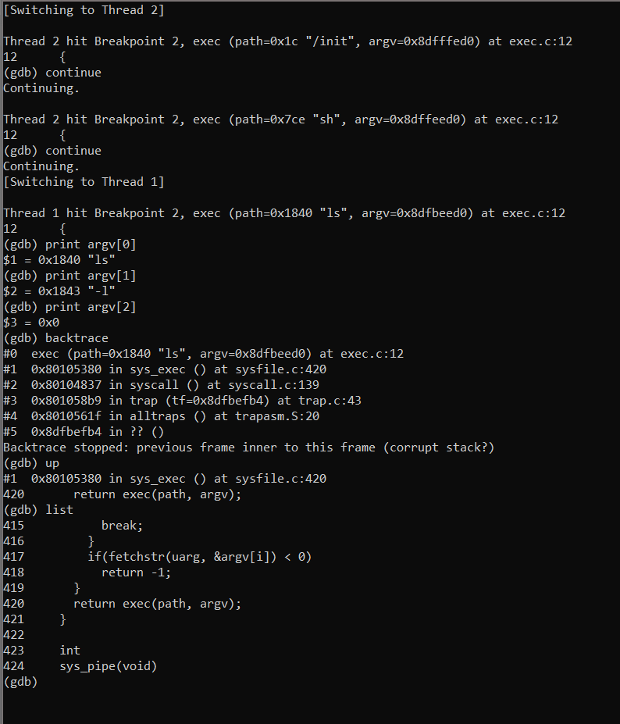

We made a breakpoint at swtch and continued to step through the code one line at a time. Then broke exec and went into a different thread. I was able to correctly recreate each of the steps the professor had instructed us to perform.

Scheduler Debug

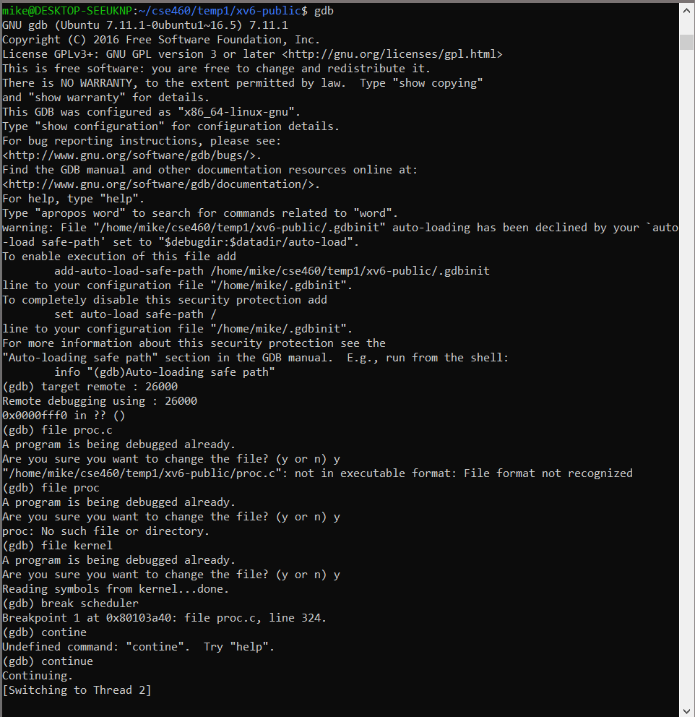

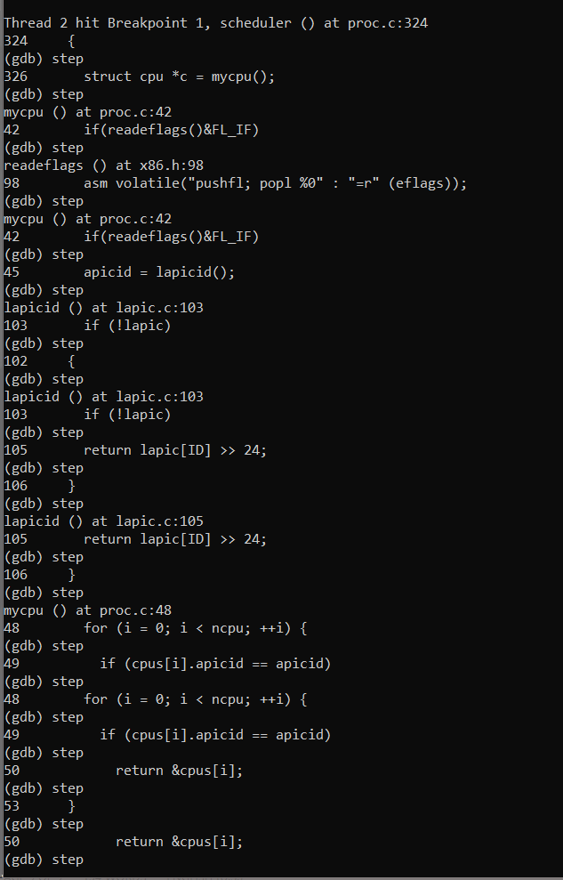

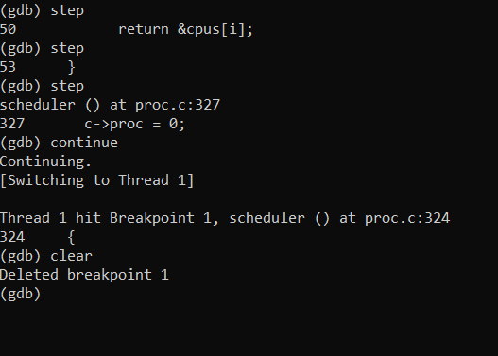

Evaluation:

I was able to successfully complete each step in the lab. Modified msgs correctly and studied the IPCS commands. As well as used the debug in xv6 on both the swtch function and the scheduler function. I believe I have earned a 20/20 for this lab